Monitor & Alerts SQL Databases

Three important parameters should be monitor

1. DTU Usage

2. CPU Usage

3. IO Usage

DTU usage:

DTU stands for Database Transaction Unit. DTUs give you a way to compare database performance across the service tiers offered by Azure. DTUs roughly measure performance as a combination of CPU, Memory, Reads, and Writes. When provisioning compute for elastic pools, the acronym eDTU may be used to refer to DTUs that are part of an elastic pool.

## Effects

Running at consistently high DTU usage, especially near 100% usage will be detrimental to the performance of your database and should be addressed ASAP. Specific issues may include:

* Longer query times
* Rejected transactions due to timeouts

Fixes

diagnosing high DTU usage is to figure out which resource is contributing to your high usage by querying the sys.dm_db_resource_stats table.

SELECT * FROM sys.dm_db_resource_stats ORDER BY end_time DESC;

important parameter to observe here

avg_cpu_precent

avg_data_io_precent

avg_log_write_precent

avg_memory_usage_precent

Refer:

https://docs.microsoft.com/en-us/sql/relational-databases/system-dynamic-management-views/sys-dm-db-resource-stats-azure-sql-database?view=azuresqldb-current

CPU usage

CPU usage is a term used to describe how much the processor is working. A computer's CPU usage can vary depending on the types of tasks that are being performed by the processor. CPU usage can be monitored to see how much of the processor's capacity is in use.

When looking at high CPU usage on a database, the culprit is very likely to be one of the following:

* Too many queries running
* Too many queries compiling
* Queries running sub-optimally

Root Cause:

Might increase Resources (last option)

IO Usage:

What is IO Process:

input/output (defined as KB/s) is just the throughput or speed of data transfer between the hard disk and the RAM. On a server, a disk I/O describes every process that involves writing to or reading from a storage device which on a shared web hosting server will be the hard disk drive, or HDD

SELECT end_time, avg_data_io_percent, avg_log_write_percent FROM sys.dm_db_resource_stats ORDER BY end_time DESC;

Root Cause:



Type of purchase model:

1. vCore

2. DTU

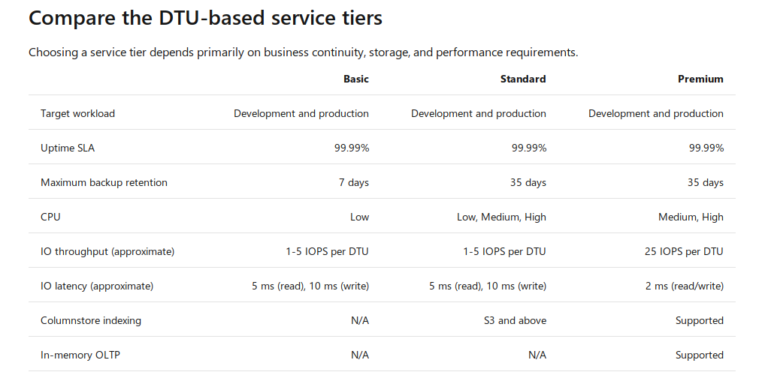

Refer: https://docs.microsoft.com/en-us/azure/sql-database/sql-database-service-tiers-dtu

Database tier:

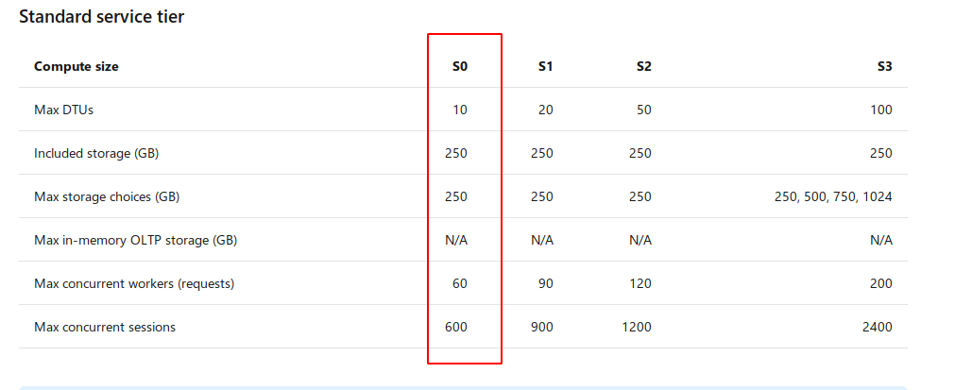

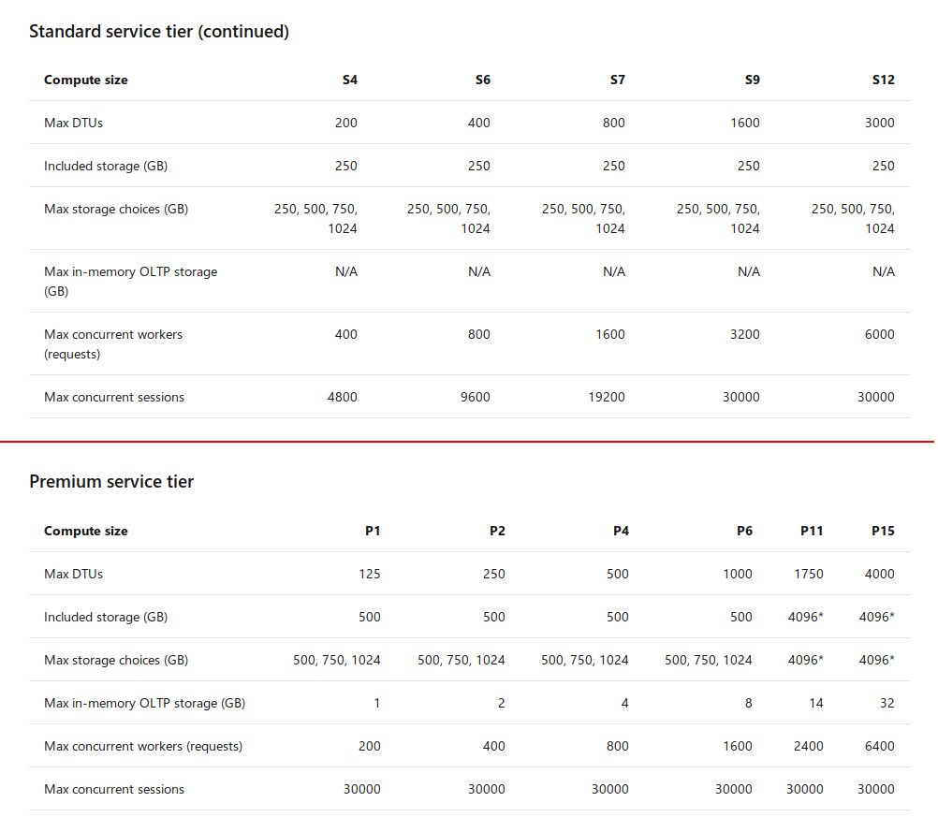

Recommended Approach

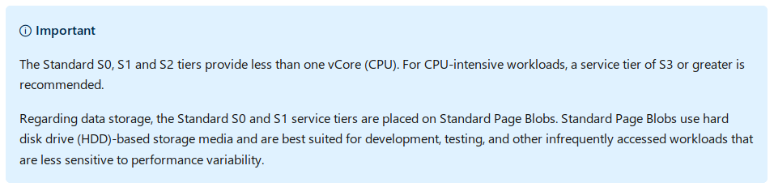

Upgrade Considerations:

1. Max concurrent sessions

2. Max concurrent requests

3. CPU Usage

4. IO usage

5. DTU Usage

Refer:

https://docs.microsoft.com/en-us/azure/sql-database/sql-database-dtu-resource-limits-single-databases

Pricing Details:

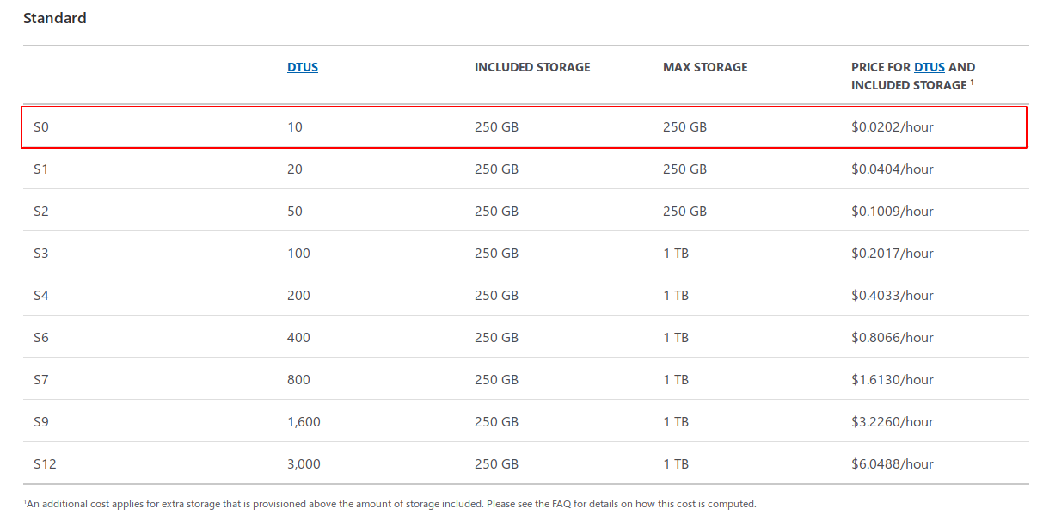

Pricing Include:

1. SQL Instance cost and DB

2. Extra Data Storage

3. Inbound Data transfer ( Free )

4. Outbound Data transfer ( 5Gb free )

Alerts:

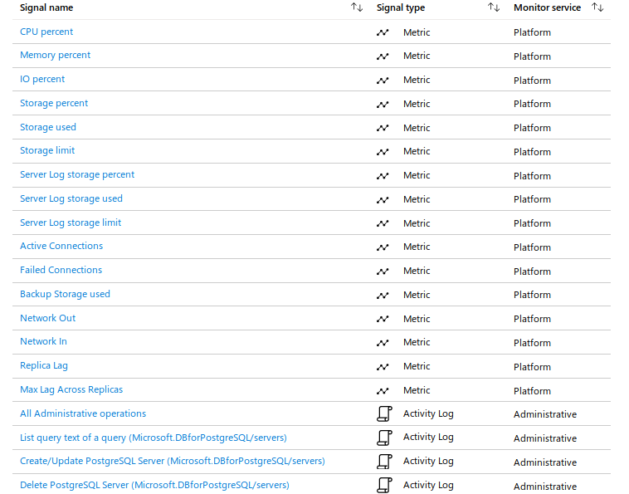

please refer the above pics by default azure provide metrics list.

Refer:

https://www.bluematador.com/docs/troubleshooting/azure-sql-dtu-usage